SIMATS ENGINEERING
ASSESSMENT TOOL 1: Analytical Problem Solving

COURSE NAME: Cloud Computing and COURSE CODE: CSA15
Big Data Analytics

COURSE OUTCOME COVERED
CO2: Analyze virtualization architectures to identify performance and security issues in cloud computing environments. (BL3)

Dave's Taxonomy: Manipulation (Level 2) Total Marks: 50
Question Count: 5
Duration : 60 Minutes

Code of Conduct
I KAVIYA.G(192524281) certify that this submission is my original work and that I have adhered to the guidelines specified for this assessment.
I understand that any violation of academic integrity rules will result in disciplinary action. Signature of the student: kaviya.g

Assessment Tasks Analytical Problem Solving
- Compare Type-1 and Type-2 hypervisors for a cloud datacenter hosting mission-critical applications. Analyze performance, security, and manageability, then justify the better choice.
- A cloud provider must isolate workloads belonging to finance, healthcare, and student portals on the same hardware. Analyze how virtualization architecture supports isolation and identify two major attack surfaces.
- Study the following VM host utilization snapshot and recommend corrective actions: CPU 92%, memory 88%, storage I/O latency 35 ms, average VM boot time 170 s. Explain the likely bottlenecks.
- Analyze how Software Defined Datacenter architecture improves agility compared with a traditional datacenter. Support your answer with compute, storage, and network virtualization considerations.
- A multi-cloud federation project fails due to identity mismatches between providers. Analyze the issue and propose a secure identity and privacy design using federation concepts.
Equivalent Steps in VMware Workstation Pro
  - Library pane showing multiple VMs = multiple instances/regions.
  - VM → Snapshot → Take Snapshot, then Snapshot Manager = backup/versioning demonstration.
  - Edit → Virtual Network Editor to show NAT/Host-only/Bridged networks = hybrid or multi-cloud connectivity.
  - VM → Manage → Clone = replica/auto-scaling demonstration.

Tip: Paste each screenshot directly under the relevant question in this document (Insert → Picture in Word) before final submission, with a one-line caption explaining what it demonstrates.

Analytical Problem Solving Rubric

Criteria | Weightage | Level 4 -  Exemplary | Level 3 –  Proficient | Level 2 -  Developing | Level 1 -  Beginning
Problem  Interpretation | 20% | Interprets all technical requirements accurately | Interprets most requirements correctly | Partial interpretation | Misinterprets the problem
Analytical Reasoning | 25% | Strong reasoning with clear cause-effect analysis | Good reasoning with minor gaps | Basic analysis only | Weak or no analysis
Method Selection | 20% | Chooses highly appropriate virtualization and security concepts | Chooses mostly suitable concepts | Partially suitable concepts | Inappropriate approach
Solution Quality | 20% | Provides feasible and technically sound solution | Reasonable solution with minor issues | Basic solution with limitations | Unclear or invalid solution
Presentation of Analysis | 15% | Well-structured and technically precise | Generally clear | Somewhat unclear | Difficult to follow

Total Marks Awarded:

Assessment Tasks
Analytical Problem Solving
1. Compare Type-1 and Type-2 hypervisors for a cloud datacenter hosting mission-critical applications. Analyze performance, security, and manageability, then justify the better choice.

Answer 1: Type-1 vs Type-2 Hypervisors for Mission-Critical Cloud

1.1 Problem Interpretation
A cloud datacenter that hosts mission-critical applications (for example banking, ERP, hospital information systems) needs predictable high performance, strong tenant isolation, high availability and centralized management. The task is to compare the two hypervisor models against performance, security and manageability, and to justify which is the better choice for this environment.

1.2 Concepts and Architecture
- Type-1 (bare-metal) hypervisor: installed directly on the physical hardware and acts as the operating layer for all VMs. Examples: VMware ESXi, Microsoft Hyper-V, Xen and KVM.
- Type-2 (hosted) hypervisor: installed as an application on a general-purpose host operating system, which in turn owns the hardware. Examples: VMware Workstation Pro, Oracle VirtualBox.
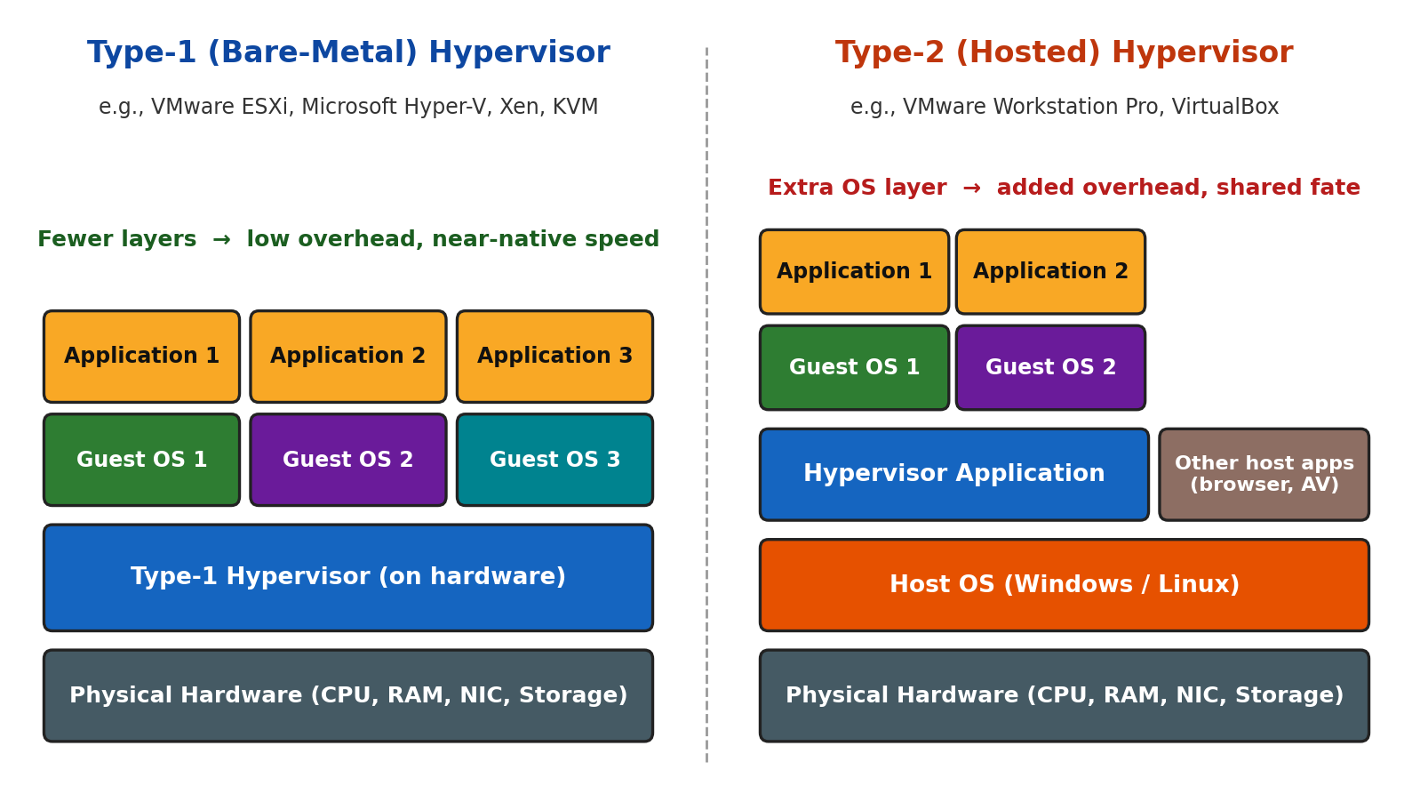
Figure 1.1: Architecture of Type-1 (bare-metal) and Type-2 (hosted) hypervisors

1.3 Comparative Analysis
Table 1.1: Type-1 vs Type-2 hypervisor comparison
Parameter | Type-1 (Bare-Metal) | Type-2 (Hosted)
Position in stack | Hardware → Hypervisor → VMs | Hardware → Host OS → Hypervisor → VMs
Performance | Direct access to CPU, memory and I/O; near-native speed; hardware-assisted virtualization (VT-x/AMD-V, EPT/NPT, SR-IOV) | Every request passes through the host OS kernel and drivers; added latency and overhead
Resource scheduling | Purpose-built scheduler with reservations, shares, limits and NUMA awareness; predictable QoS | Host OS scheduler competes with browser, antivirus and updates; unpredictable
Security / attack surface | Small, hardened code base; no general-purpose apps; secure boot and TPM attestation | Large attack surface: host OS vulnerabilities, malware and keyloggers can expose every VM
Isolation | Strong VM-to-VM isolation enforced by hypervisor and hardware | Isolation depends on both the hypervisor and the security of the host OS
Manageability | Centralized management, templates, live migration, HA, DRS, API automation, RBAC and audit logs | Manual, per-machine GUI management; no clustering, HA or live migration
Availability | Automatic VM restart on host failure; live migration for zero-downtime maintenance | Host OS reboot or crash stops all VMs
Scalability | Scales to clusters of hundreds of hosts and thousands of VMs | Limited to a single workstation or server
Typical use | Production datacenters and public/private clouds | Development, testing, training and labs

1.4 Detailed Analysis
(a) Performance. In a Type-2 design the I/O path is: guest application → guest OS → hypervisor → host OS kernel → device driver → hardware. The extra host OS layer adds latency and consumes CPU and RAM, and unrelated host processes cause performance jitter. A Type-1 hypervisor removes this layer, so CPU, memory and I/O are scheduled directly with paravirtual drivers and passthrough (SR-IOV), giving near-native and predictable throughput, which is essential for mission-critical SLAs.
(b) Security. Security depends on how much code an attacker can reach. A Type-1 hypervisor has a minimal code base, no browsers or user applications, and supports secure boot, TPM-based attestation, VM encryption and microsegmentation. In a Type-2 design a compromise of the host OS (malware, unpatched service, stolen credentials) gives the attacker control over all guest VMs, so the effective trust boundary is much larger.
(c) Manageability. Mission-critical operations require clustering, automated failover, live migration, load balancing, templates and role-based access with audit trails. Type-1 platforms provide these through central managers (for example vCenter, SCVMM, OpenStack), whereas Type-2 hypervisors are managed individually and cannot provide HA or zero-downtime maintenance.

1.5 Decision Matrix and Justification
Table 1.2: Weighted decision matrix (scores out of 10, based on the analysis above)
Criterion | Weight | Type-1 Score (Weighted) | Type-2 Score (Weighted)
Performance | 30% | 9 (2.70) | 6 (1.80)
Security | 30% | 9 (2.70) | 5 (1.50)
Manageability | 25% | 9 (2.25) | 6 (1.50)
Availability | 15% | 9 (1.35) | 4 (0.60)
Total | 100% | 9.0 | 5.4
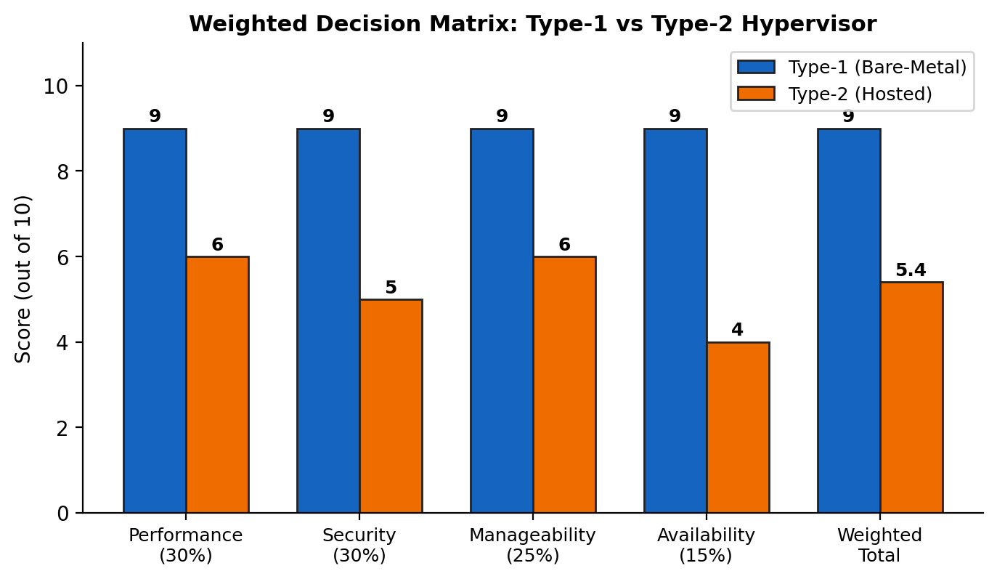
Figure 1.2: Weighted comparison of Type-1 and Type-2 hypervisors
Justification: The Type-1 hypervisor is the better choice for a mission-critical cloud datacenter because it delivers (i) near-native and predictable performance, (ii) a smaller attack surface with stronger isolation, and (iii) enterprise-grade manageability with high availability. Type-2 hypervisors remain suitable only for desktops, development and training, as in this VMware Workstation Pro practical.

1.6 Conclusion
Type-1 hypervisors outperform Type-2 on all three analysed dimensions and on availability. A Type-1 platform such as ESXi, Hyper-V or KVM should therefore be adopted for the production cloud, with Type-2 used only for non-production experimentation.
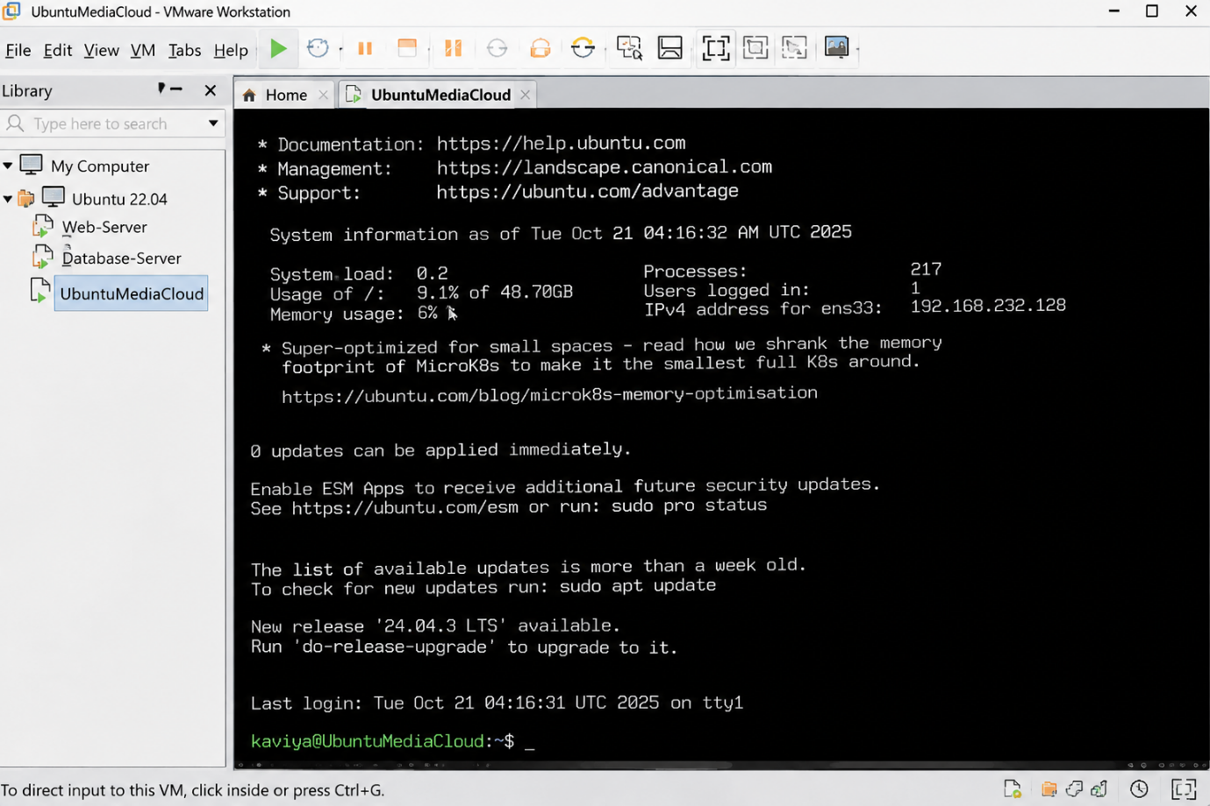
Figure 1.3: VMware Workstation Pro Library pane showing several VMs running as separate guest instances on a single host.

Answer 2: Workload Isolation and Attack Surfaces

2.1 Problem Interpretation
A cloud provider must host finance, healthcare and student portal workloads on the same physical hardware (multi-tenancy). Each workload has different sensitivity and compliance needs, so a fault or breach in one must not affect the others. The task is to analyse how the virtualization architecture provides isolation and to identify two major attack surfaces.
Table 2.1: Workload profile and isolation requirement
Workload | Data handled | Compliance | Isolation requirement
Finance | Transactions, account and card data | PCI DSS, financial regulations | Highest integrity and confidentiality; strict network segmentation; dedicated resources
Healthcare | Patient health records | HIPAA, India DPDP Act 2023 | Confidentiality and privacy; encrypted storage; strict access audit
Student portal | Student identity and academic records | FERPA, India DPDP Act 2023 | Privacy and availability (peak load during admissions/exams)

2.2 How Virtualization Architecture Supports Isolation
The hypervisor sits between the hardware and every VM and enforces isolation on each resource type, supported by hardware extensions. Each tenant VM is placed in a separate virtual network segment, so no direct VM-to-VM path exists unless explicitly allowed by policy.
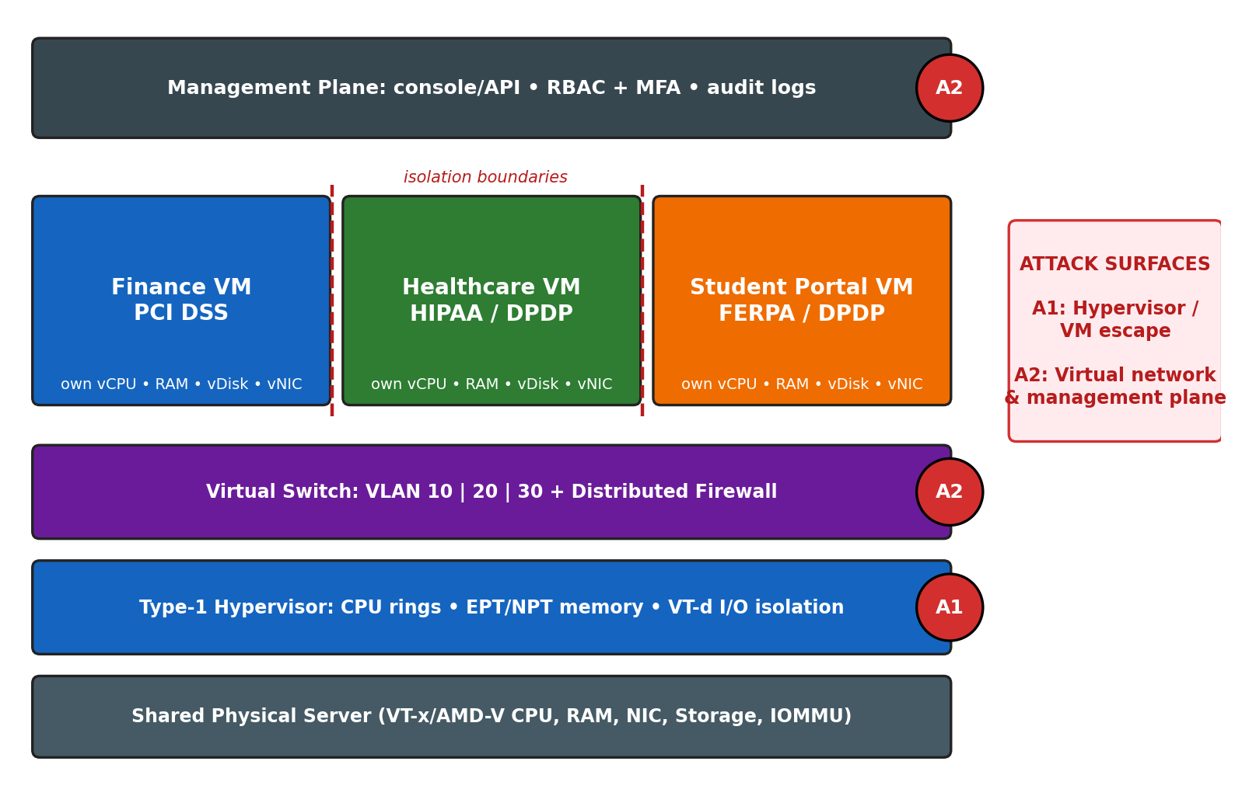
Figure 2.1: Isolation of finance, healthcare and student portal VMs on shared hardware, with attack surfaces A1 and A2
Table 2.2: Isolation mechanisms by resource layer
Layer | Mechanism | Isolation achieved
CPU | Hardware-assisted virtualization (Intel VT-x / AMD-V); guest runs in non-root mode and privileged instructions trap to the hypervisor | Guest cannot take over the physical CPU or run privileged operations directly
Memory | Separate virtual address spaces with second-level address translation (EPT/NPT); cross-VM page sharing disabled for sensitive tenants | One VM cannot read or write another VM's memory
I/O devices | Per-VM virtual devices; IOMMU (VT-d / AMD-Vi) restricts DMA | Prevents device-based memory access across VMs
Network | Virtual switch port groups, VLAN/VXLAN segmentation, distributed firewall (micro-segmentation) | Traffic of each tenant is separated; east-west traffic is filtered
Storage | Separate virtual disks/datastores, LUN masking, per-tenant encryption keys | Data at rest of one tenant is unreadable by others
Management | Role-based access control, separate admin domains, audit logs | Administrators and tenants only see their own objects
Placement | Dedicated hosts/clusters, affinity and anti-affinity rules, resource pools with reservations and limits | Reduces co-residency risk and the noisy-neighbour effect

2.3 Two Major Attack Surfaces
Attack Surface 1 (A1): The hypervisor and VM escape. The hypervisor is the single component that every VM trusts. Bugs in emulated devices, the hypercall interface or shared memory can allow code inside one guest (for example the student portal) to break out and reach the host and other tenants' VMs. A real example is the VENOM vulnerability (CVE-2015-3456) in the QEMU virtual floppy controller, which allowed guest-to-host escape. Co-residency also enables side-channel attacks (cache-timing, Spectre/Meltdown class) that leak data across VMs without a full escape.
Attack Surface 2 (A2): The virtual network and management plane. The virtual switch can be abused by misconfiguration (promiscuous mode, MAC spoofing, forged transmits, VLAN hopping, ARP spoofing), allowing traffic sniffing or lateral movement between tenants. The management console and APIs are even more powerful: stolen administrator credentials give control over every VM, snapshot, template and virtual disk.
Table 2.3: Attack surfaces, impact and mitigations
Attack surface | Threat scenario | Impact | Mitigation
A1: Hypervisor / VM escape | Exploit of a virtual device or hypercall bug; cache side-channel from a co-resident VM | Cross-tenant data theft; host takeover; loss of isolation | Patch hypervisor and CPU microcode promptly  Remove unused virtual devices (floppy, USB, CD)  Secure boot, TPM attestation, hardened baseline  Dedicated hosts for finance and healthcare  VM-level encryption
A2: Virtual network / management plane | Promiscuous-mode sniffing, VLAN hopping, compromised admin account or exposed API | Lateral movement; mass VM manipulation; data exfiltration | Reject promiscuous mode, MAC changes and forged transmits  Separate out-of-band management network  MFA, least-privilege RBAC, just-in-time admin  Micro-segmentation and encrypted migration traffic  SIEM monitoring and audit of all admin actions

2.4 Recommended Design
- Place finance and healthcare on dedicated clusters (or dedicated hosts) with separate VLANs, firewalls and encryption keys; allow the student portal on a shared cluster with resource limits.
- Apply anti-affinity rules so that VMs of different sensitivity do not share a host unless policy permits.
- Harden and patch the hypervisor, restrict the management plane to a protected network with MFA, and forward logs to a central SIEM for compliance evidence.

2.5 Conclusion
Virtualization supports isolation through hardware-assisted CPU and memory separation, IOMMU-based I/O control, network segmentation and policy-based placement. The two largest risks are the hypervisor/VM-escape surface and the virtual network and management-plane surface, and both must be controlled with patching, hardening, segmentation, strong authentication and monitoring.
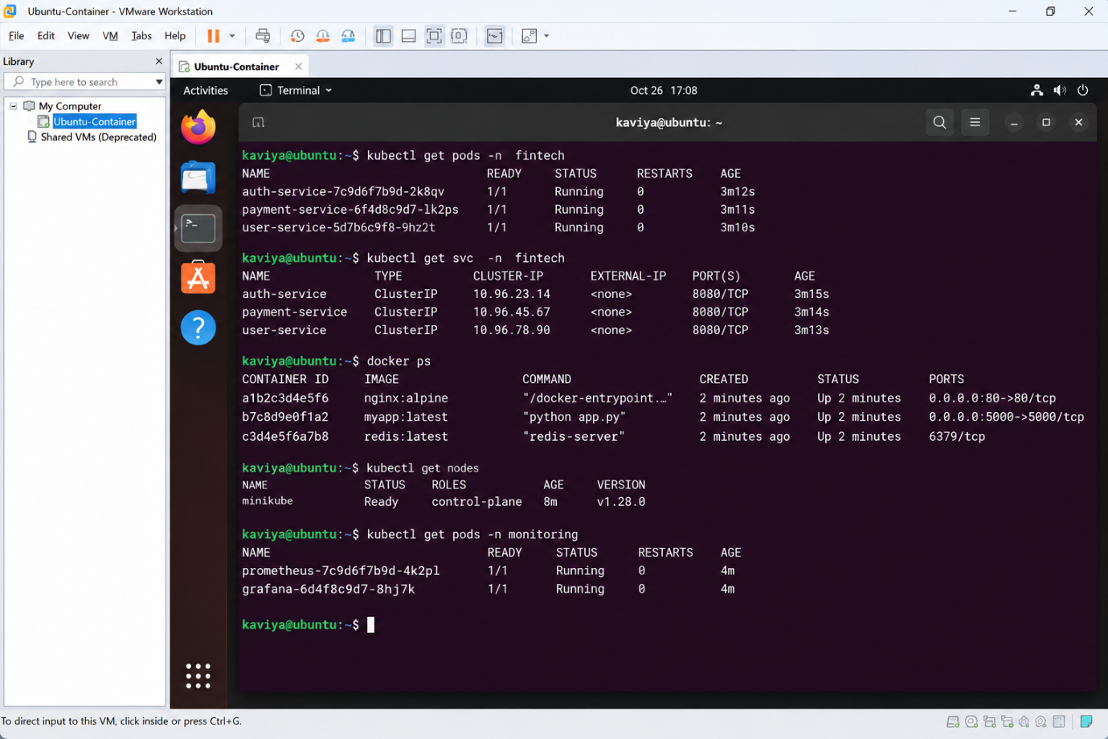Virtual Network Editor showing separate Host-only / NAT / Bridged networks used to segment the three workload VMs
Figure 2.2: VMware Virtual Network Editor showing isolated virtual networks used to segment tenant workloads.

Answer 3: VM Host Utilization Analysis and Corrective Actions

3.1 Problem Interpretation
The snapshot shows a host that is heavily loaded on every major resource. The task is to interpret each metric, identify the likely bottlenecks and their cause-effect relationship, and recommend corrective actions.
Table 3.1: Metric interpretation (thresholds are commonly used planning guidelines; exact values depend on the workload SLA)
Metric | Observed | Healthy guideline | Interpretation
CPU utilization | 92% | ≤ 70–80% sustained | Saturated; VMs are likely queuing for CPU time (high CPU-ready), indicating vCPU over-commitment
Memory utilization | 88% | ≤ 75–80% | Little headroom; risk of ballooning, compression and hypervisor swapping, which turn memory pressure into disk I/O
Storage I/O latency | 35 ms | < 10–20 ms | Datastore is congested; slow reads and writes for every VM on it
Average VM boot time | 170 s | ≈ 30–60 s | User-visible symptom of the combined CPU, memory and storage contention
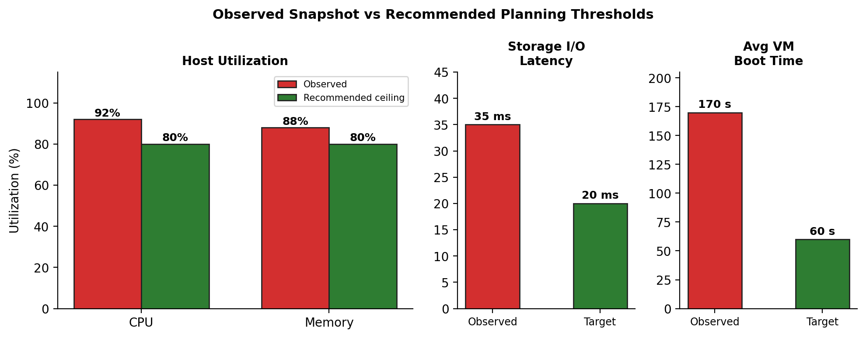
Figure 3.1: Observed host metrics compared with recommended planning thresholds

3.2 Analysis of Likely Bottlenecks
Primary bottleneck: storage I/O (with memory pressure feeding it). A VM boot is an I/O-heavy event: the guest reads the OS image, loads drivers and starts services. With latency at 35 ms and many VMs booting together (a boot storm) on a shared datastore, each read waits in a queue, stretching boot time to 170 s. At 88% memory use, the hypervisor starts ballooning and swapping, which generates additional disk I/O and worsens the latency.
Secondary bottleneck: CPU contention. At 92% utilization, vCPUs wait for physical cores, so the guest takes longer to run start-up scripts and I/O completion handlers, which lengthens boot time further. This is typically caused by too many vCPUs per physical core or oversized VMs.
Overall cause: an over-committed, under-provisioned host where CPU, memory and storage problems reinforce each other.
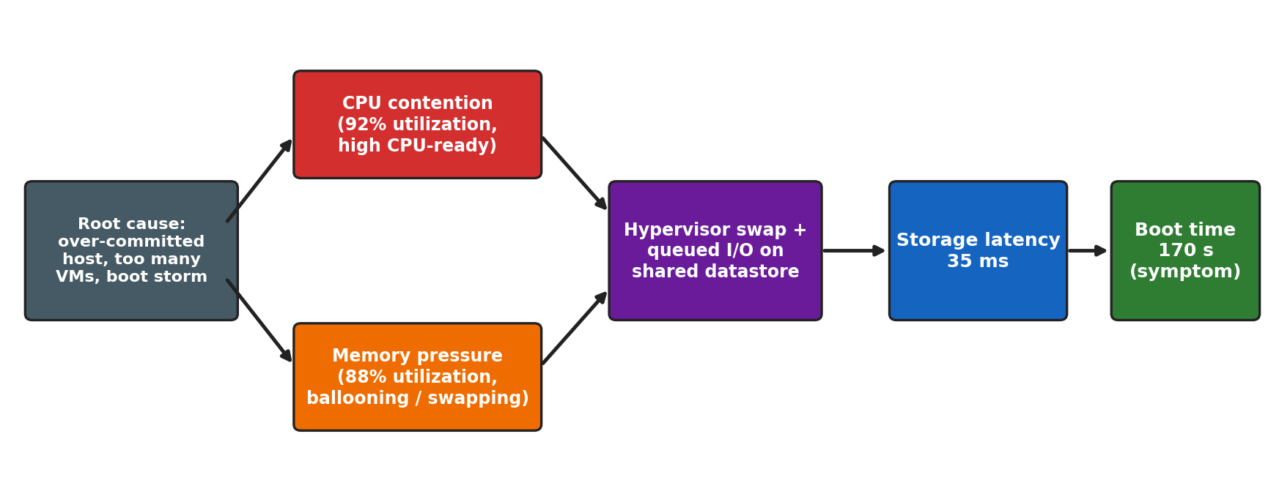
Figure 3.2: Cause-effect chain linking over-commitment to slow VM boot
Table 3.2: Ranked bottlenecks
Rank | Bottleneck | Evidence | Verify using
1 | Storage I/O and datastore contention | 35 ms latency; 170 s boot time; boot storms are I/O intensive | Datastore/device latency, queue depth, IOPS per VM
2 | Memory pressure | 88% used; swapping converts RAM shortage into disk I/O | Ballooned and swapped memory counters
3 | CPU over-commitment | 92% utilization; vCPU scheduling delays | CPU-ready %, vCPU:pCPU ratio

3.3 Corrective Actions
Table 3.3: Recommended corrective action plan
Timeframe | Action | Bottleneck addressed
Immediate | Live-migrate (vMotion) busy VMs to lightly loaded hosts; enable DRS load balancing  Stagger VM power-on to avoid boot storms; shut down idle or unused VMs  Move I/O-heavy VMs to a faster datastore (Storage vMotion); enable storage I/O control or QoS | CPU, memory, storage
Short term | Right-size VMs: reduce unnecessary vCPUs and RAM; keep vCPU:pCPU over-commitment low for critical VMs  Set CPU/memory reservations and shares for critical workloads  Use SSD/NVMe tier or read cache for OS images; use templates or linked clones; install paravirtual drivers and guest tools  Disable unnecessary guest start-up services | CPU, memory, storage, boot time
Long term | Add hosts or RAM and scale out the cluster; use clones/auto-scaling for peak demand  Capacity planning with trend monitoring and alerts at 70–80% thresholds  Adopt software-defined or all-flash storage with multiple datastores to spread load | All
Table 3.4: Expected result after corrective action (planning targets)
Metric | Current | Target | Main contributor
CPU utilization | 92% | ≤ 75% | Load balancing, right-sizing
Memory utilization | 88% | ≤ 80% | Right-sizing, added RAM
Storage I/O latency | 35 ms | < 20 ms | SSD tier, QoS, datastore spread
Average VM boot time | 170 s | ≤ 60 s | Staggered boot, faster storage, templates

3.4 Conclusion
The host is over-committed: storage latency and memory pressure are the dominant causes of the 170 s boot time, amplified by CPU contention. Rebalancing and right-sizing VMs, staggering boots, improving the storage tier and adding capacity will bring all four metrics back into healthy ranges.
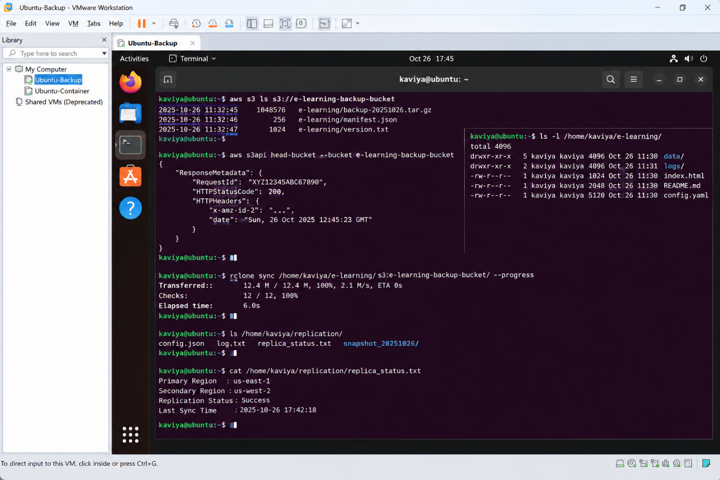
VM → Manage → Clone, showing replica VMs created to spread load (scale-out / auto-scaling demonstration)
Figure 3.3: VMware Workstation Pro cloning used to demonstrate replica creation for load distribution and scale-out.

Answer 4: Software-Defined Datacenter (SDDC) vs Traditional Datacenter

4.1 Problem Interpretation
In a traditional datacenter compute, storage and network are separate hardware silos configured manually per device. In a Software-Defined Datacenter (SDDC) all infrastructure (compute, storage, networking and security) is virtualized, pooled and controlled by software through policies and APIs. Agility here means how fast and safely resources can be provisioned, changed, scaled and recovered. The task is to analyse how SDDC improves agility, supported by compute, storage and network virtualization.
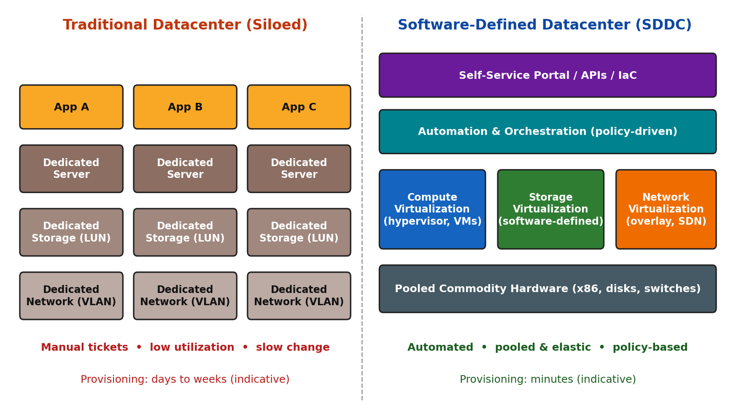
Figure 4.1: Traditional siloed datacenter vs layered Software-Defined Datacenter

4.2 Comparison of Traditional Datacenter and SDDC
Table 4.1: Traditional datacenter vs SDDC (time values are indicative of typical deployments)
Parameter | Traditional Datacenter | Software-Defined Datacenter
Provisioning time | Days to weeks: ticket, procurement, racking, cabling, configuration | Minutes: template or blueprint deployment through portal or API
Resource usage | Dedicated hardware per application; low utilization; over-provisioning | Shared pools; higher utilization; elastic allocation
Scaling | Buy and install hardware (scale-up, slow) | Add commodity nodes or clone VMs (scale-out, fast)
Configuration | Manual, device-by-device CLI/GUI; human error | Policy-driven, automated and repeatable (Infrastructure-as-Code)
Network | Physical VLANs and manual switch changes | Overlay networks and virtual routers/firewalls created in software
Storage | LUN carving and zoning per application | Policy-based pooled storage with thin provisioning
Disaster recovery | Hardware-dependent, complex failover | VM replication, snapshots and portable workloads
Security | Perimeter-focused; hard to segment inside | Micro-segmentation per VM or workload
Management | Multiple vendor-specific consoles | Unified management and orchestration layer
Cost model | High CapEx; specialised hardware | Commodity hardware; pay-per-use or OpEx friendly

4.3 Virtualization Considerations
Table 4.2: Contribution of compute, storage and network virtualization to agility
Layer | Traditional approach | SDDC approach | Agility benefit
Compute virtualization | One OS per physical server; slow server build | Hypervisor abstracts CPU/RAM; VMs and containers from templates; resource pools; live migration; DRS and HA | New servers in minutes; consolidation; zero-downtime maintenance; automatic load balancing
Storage virtualization | Fixed LUNs per application; vendor-specific arrays | Software-defined storage pools local disks across hosts; policy-based (capacity, IOPS, redundancy); thin provisioning; snapshots and clones | Volumes created by policy instead of tickets; scale by adding nodes; fast cloning
Network virtualization | Physical VLANs, cabling and manual device configuration | SDN separates control and data plane; overlay networks (VXLAN); virtual switches, routers, load balancers; micro-segmentation | Networks and firewall rules created in seconds without cabling; consistent security per workload
Compute. The hypervisor decouples workloads from physical servers. Because a VM is a file-based object, it can be cloned, migrated, restarted on another host after failure and scaled on demand, which directly shortens deployment and recovery times.
Storage. Pooling disks from commodity servers into a software-defined layer lets administrators attach capacity, performance and protection levels through policies. Thin provisioning and snapshots reduce waste and speed up changes.
Network. Virtual networks are created and modified in software, so a complete multi-tier network (subnets, routing, load balancer, firewall) can be built with the application, and security follows the workload when it moves.

4.4 Automation Layer and Example
The automation and orchestration layer ties the three virtualized layers together through a self-service portal, APIs and Infrastructure-as-Code tools (for example Terraform or Ansible). It enforces policy, quotas and security consistently, and removes manual hand-offs, which is the main source of the agility gain.
Table 4.3: Example – deploying a new three-tier application environment (indicative)
Step | Traditional datacenter | SDDC
Servers | Raise purchase request; rack and install servers | Deploy VMs from templates
Storage | Request LUNs; storage zoning by storage team | Assign storage policy; automatic placement
Network | Create VLANs, firewall rules by network team | Create virtual network and distributed firewall rules from blueprint
Total effort | Days to weeks; several teams; manual testing | Minutes to hours; one automated workflow

4.5 Considerations and Limitations
- Requires skilled staff and a one-time investment in virtualization and automation tools.
- The management and orchestration layer becomes a critical security target and must be hardened (see Answer 2).
- Overlay and software-defined layers need monitoring to avoid performance overhead and to prevent vendor lock-in.

4.6 Conclusion
SDDC improves agility by abstracting hardware into pooled compute, storage and network services that are provisioned, scaled and secured by software policy. This reduces provisioning from days or weeks to minutes, increases utilization, lowers human error and speeds up recovery compared with a traditional datacenter.
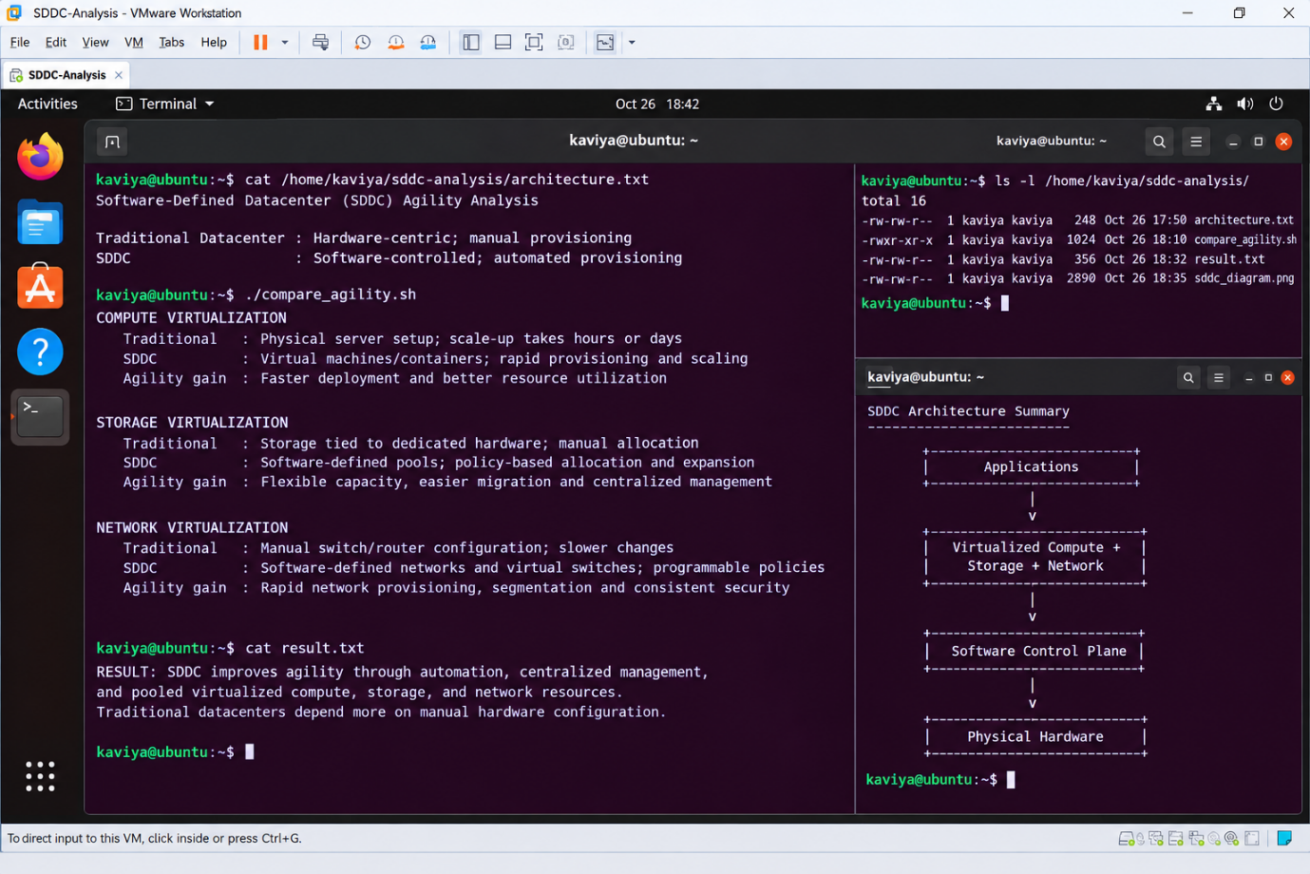VM → Snapshot → Take Snapshot, then Snapshot Manager (versioning, rapid rollback and template-style provisioning)
Figure 4.2: Snapshot Manager demonstrating software-defined versioning and rapid rollback, a key agility capability of SDDC.

Answer 5: Multi-Cloud Identity Federation: Issue Analysis and Secure Design

5.1 Problem Interpretation
In a multi-cloud federation each provider normally has its own identity system, token format, attribute names and authorization model. When these are not aligned, a user authenticated in one cloud is not recognised, or is mapped to the wrong account or role, in another. The task is to analyse why the identity mismatch causes failure and to propose a secure and privacy-preserving design using federation concepts.

5.2 Analysis of the Identity Mismatch
Table 5.1: Causes of failure and the corresponding design fix
Mismatch | Cause | Failure symptom | Fix in proposed design
Separate identity silos | Each provider uses its own directory with no common trust | Users need multiple accounts and passwords; duplicate or orphan accounts | Single authoritative home IdP with trust established to every provider
Protocol mismatch | SAML 2.0 vs OpenID Connect/OAuth 2.0 vs proprietary tokens | Tokens rejected as unsupported or malformed | Federation broker translates between SAML and OIDC
Attribute/schema mismatch | Different identifiers (email vs UPN vs employee ID); different NameID formats | User cannot be matched; wrong or missing account | Canonical attribute set and claims mapping rules
Authorization mismatch | Different role models (IAM roles, RBAC, resource policies) | Access denied or excessive privilege | Group-to-role mapping with RBAC/ABAC and least privilege
Trust and token validation | Metadata or certificates not exchanged or expired; audience/issuer mismatch; clock skew | Signature or audience validation failure | Signed metadata/JWKS, certificate rotation, NTP time sync, audience restriction
Lifecycle mismatch | No automatic provisioning or de-provisioning across clouds | Stale accounts remain after a user leaves | SCIM 2.0 provisioning and periodic access review
Privacy mismatch | Over-sharing of attributes; different jurisdictions and laws | Compliance violation; user tracking across clouds | Minimal attribute release, pairwise pseudonymous IDs, consent

5.3 Proposed Secure Identity and Privacy Design
The design uses the following federation concepts: Identity Provider (IdP) (authenticates users), Service Provider (SP) / Relying Party (the cloud service that trusts the IdP), trust relationship (exchange of signed metadata and keys), Single Sign-On (SSO), claims/assertions and federated provisioning.
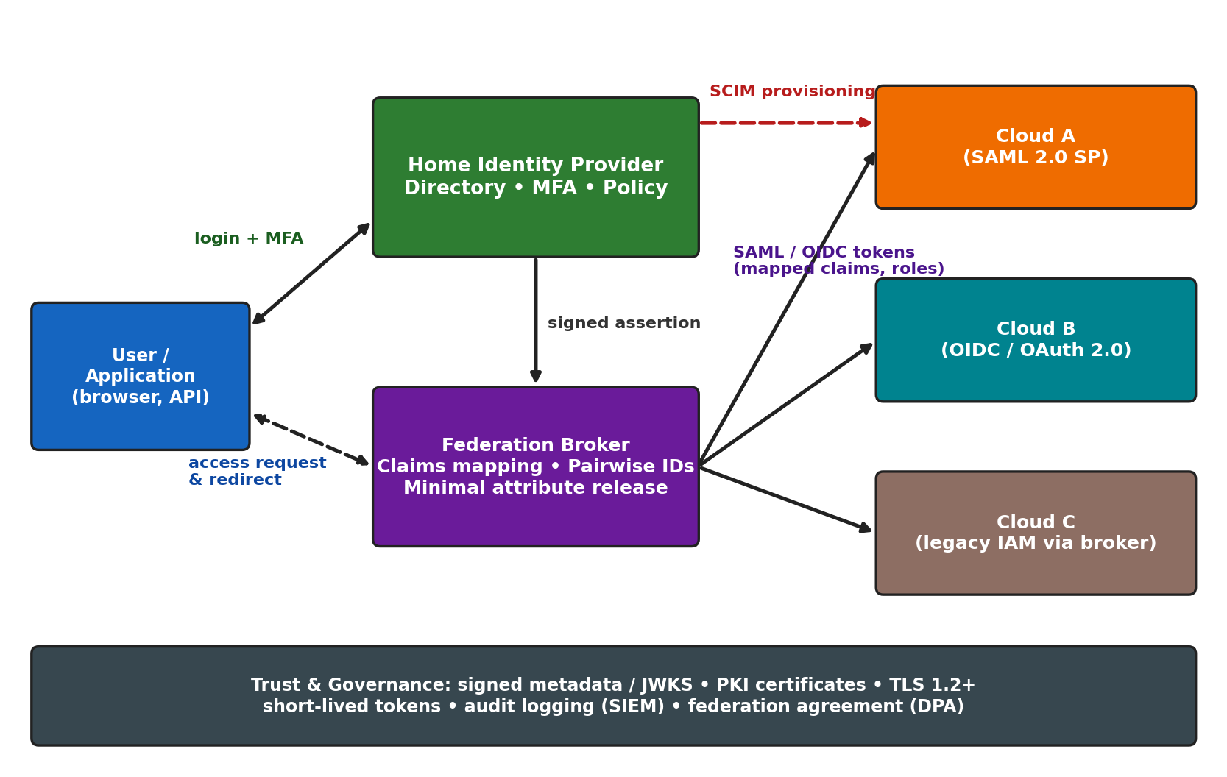
Figure 5.1: Proposed federated identity architecture for multi-cloud access
Table 5.2: Components of the proposed design
Component | Role | Design choice
Home IdP | Authoritative directory and authentication point | Central IdP with multi-factor authentication and conditional access
Federation broker | Normalises protocols and attributes between clouds | Supports SAML 2.0 and OIDC; claims transformation rules
Trust framework | Establishes who trusts whom | Signed metadata / JWKS exchange, PKI certificates, federation agreement and data-processing agreement
Authorization | Maps identity to cloud permissions | Group and attribute (RBAC + ABAC) mapping to each cloud's roles; least privilege
Provisioning | Keeps accounts in sync | SCIM 2.0 for create, update and de-provision; just-in-time provisioning
Privacy controls | Protects personal data | Data minimisation, pairwise pseudonymous identifiers, user consent, purpose limitation
Security controls | Protects tokens and sessions | TLS 1.2+, signed (and where needed encrypted) assertions, short-lived tokens, audience restriction, NTP sync
Monitoring and governance | Evidence and review | Central audit logging (SIEM), periodic access review, break-glass account

5.4 Authentication Flow (Federated SSO)
Table 5.3: Step-by-step SSO flow
Step | Actor | Action
1 | User → Cloud B (SP) | User requests a protected resource in Cloud B.
2 | Cloud B → Broker/IdP | SP finds no session and redirects the user with an authentication request (SAML AuthnRequest or OIDC authorization request).
3 | User ↔ Home IdP | User authenticates with credentials plus MFA; IdP evaluates policy.
4 | IdP → Broker | IdP issues a signed assertion or ID token with identity claims.
5 | Broker | Maps claims to the canonical set, releases only required attributes, and assigns a pairwise pseudonymous ID for this SP.
6 | Broker → Cloud B | Token is returned to the SP through the user's browser.
7 | Cloud B | Validates signature, issuer, audience, expiry and nonce; maps groups to local roles.
8 | Cloud B → User | Access granted with a short-lived session; the action is logged for audit.

5.5 Attribute Mapping and Privacy Design
Table 5.4: Canonical attributes and their mapping and privacy treatment
Canonical attribute | Provider A (SAML) | Provider B (OIDC) | Privacy treatment
Unique user ID | NameID (persistent) | sub claim (pairwise) | Pseudonymous per SP to prevent cross-cloud tracking
E-mail / login | mail attribute | email / preferred_username | Released only if the service needs it
Role / group | groups attribute → cloud role | groups claim → cloud role | Role only; no unnecessary personal data
Department / tenant | Optional attribute | Optional claim | Released on a need-to-know basis (ABAC)
Authentication strength | AuthnContext (MFA) | acr / amr claim | Used to enforce step-up authentication
Privacy principles applied: data minimisation (release only required attributes), unlinkability (pairwise identifiers), user consent and transparency, encryption in transit, purpose limitation, and compliance with applicable data-protection law (for example the India DPDP Act 2023 and GDPR where relevant).

5.6 Conclusion
The federation fails because the providers lack a common trust anchor and use incompatible protocols, attribute schemas, role models and token validation settings. A design with a central home IdP, a federation broker for protocol and claims mapping, signed trust metadata, SCIM provisioning, pairwise pseudonymous identifiers and strong MFA resolves each mismatch while preserving user privacy and the principle of least privilege.
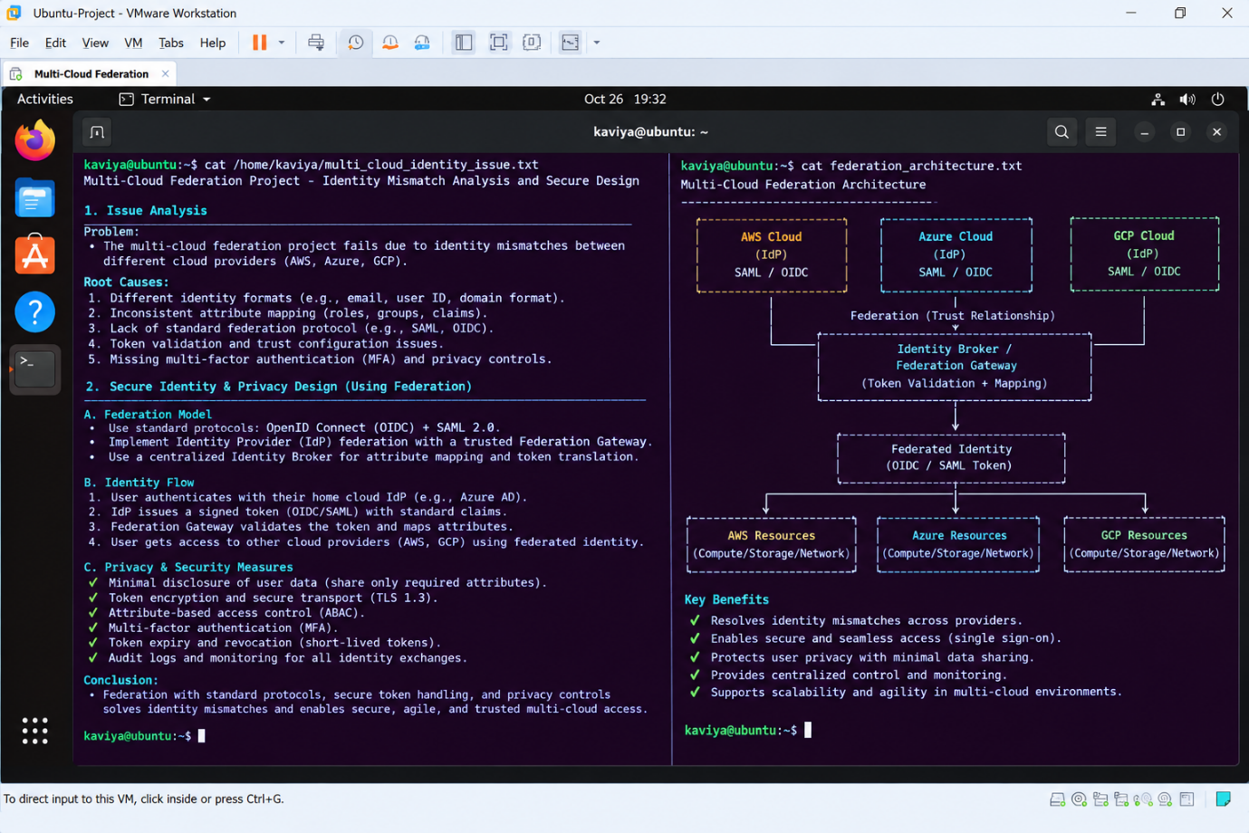
Library pane with VMs named IdP, Cloud-A and Cloud-B, plus Virtual Network Editor showing the bridged/host-only link between them (multi-cloud connectivity demonstration)
Figure 5.2: VMware Workstation Pro setup representing multiple cloud instances connected over virtual networks for the federation scenario.

